Implementing Simple Functional Programs in LISP

Emmanuel Ameh

Implementing Simple Functional Programs in LISP

Lisp is a functional program developed in the mid-twentieth century as has many uses in industries including the Artificial Intelligence (AI) industry. It is machine-independent and has features for easy extensibility. It has relevance in object-oriented programming and provides design methodology. It is beginning to find use again in several industries as a formidable procedural programming language for executing functional programs. It is also a high-level programming language and provides extensive control structures. A LISP interpreter, GNU CLISP 2.49 was downloaded to complete the assignment. It was used in implementing the program codes in the assignment.

**LISP program to display the message, “Hello, world!”**

**Code**

;;;Lisp Program to output “Hello World”

>>(print “Hello World”)

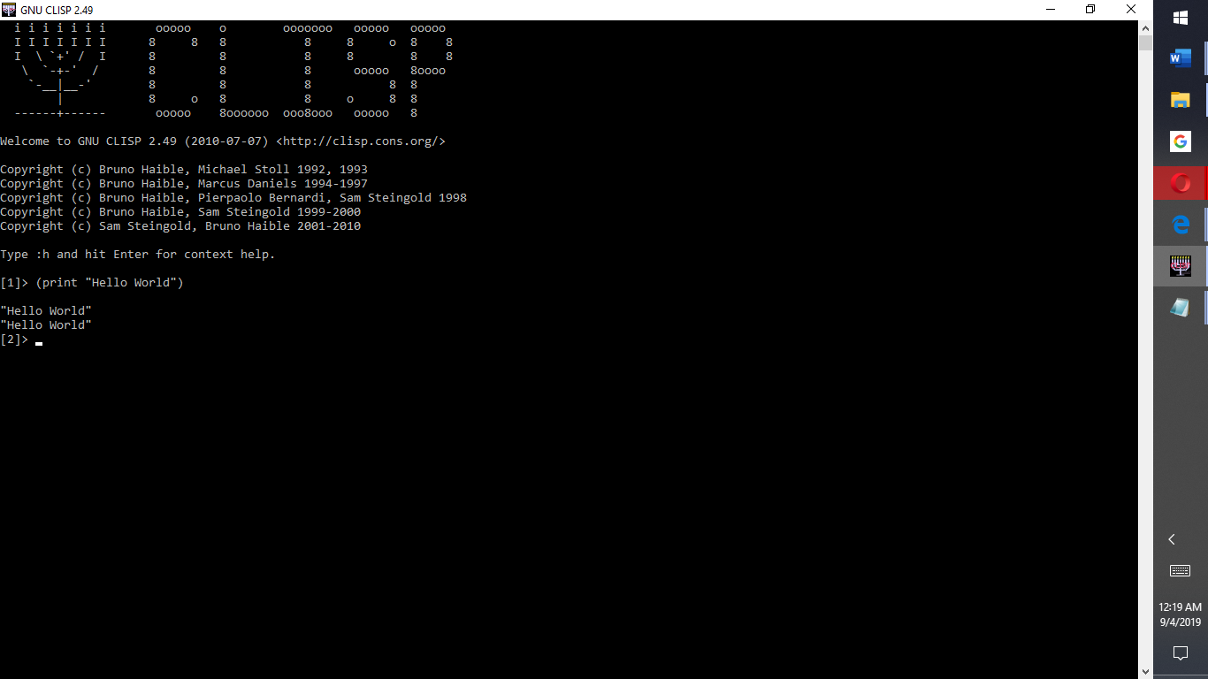

**LISP program to convert temperature from degrees Fahrenheit to degrees Celcius**

**Code**

;;; Function, to convert a specific temperature in degrees Fahrenheit to degrees Celsius,

(defun convert ()

(format t "Enter Fahrenheit:")

(LET (fahre)

(SETQ fahre (read fahre))

(APPEND '(celsisus is) (*(- fahre 32)(/ 5 9)) )

)

)

;;;To print the converted temperature from Fahrenheit to Celcius.

(print"Temperature of 160 degrees Fahrenheit converted to Celcius is:")

(print (*(- 160 32)(/ 5 9)))

**CLISP Output**

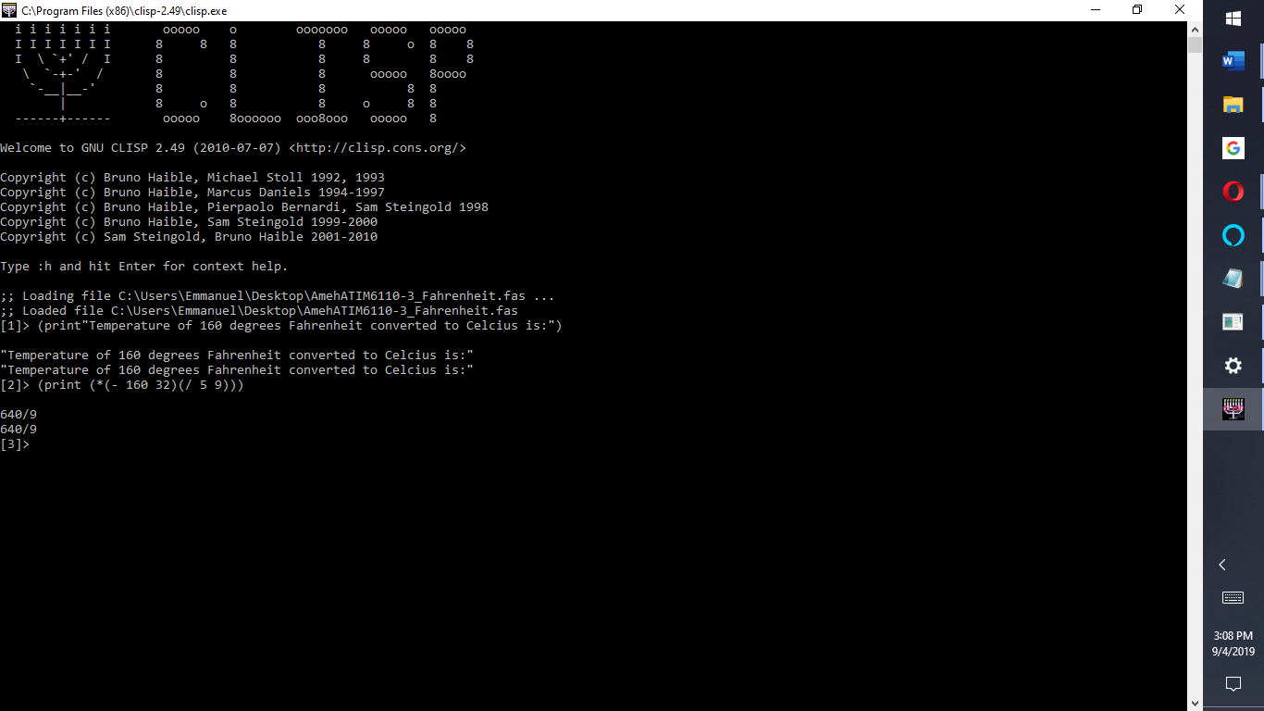

**LISP program to Reverse sentence string (Palindromes)**

**Code**

;;; Lisp programming code to output the reverse of 'This is my life'

* (print (reverse "This is my life!"))

> (print (reverse "popular mirror image words are AA TAT WOLLOW VAV MUM TIT OHO HAH MA'AM MAM TOT TOOT MOM WOW”)

**CLISP Output**

